Format Drifting Bottles
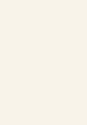
Warna : Pastel Cream (#f8f3e9), Light Cyan (#bffffc)

Tipografi :
- Source Serif Pro Bold (Header)
- Nunito light (Main Text)
- Italianno (Message Text)
Ukuran Website :
- Desktop (1680x1050 px)
- Mobile (420x320 px)
Object : Ilustrasi
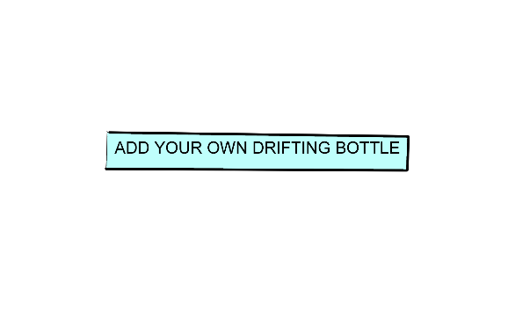
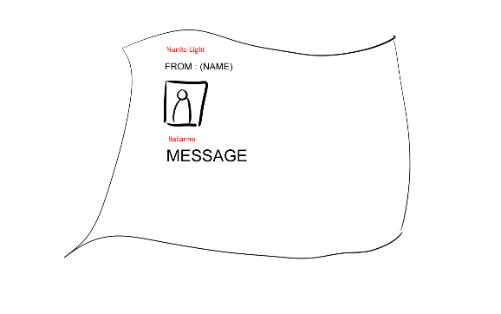
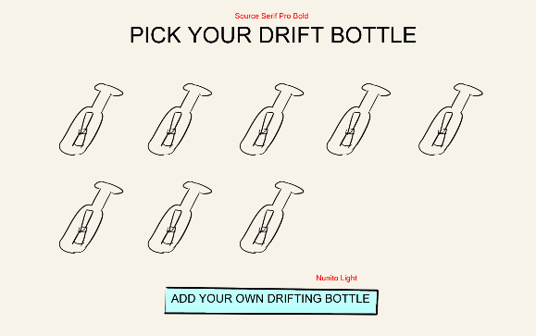
Rough Sketch:
